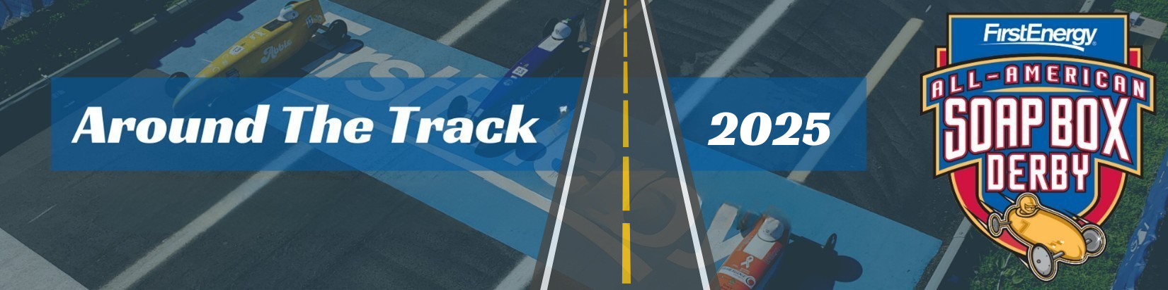

|  |  |  |
| --- | --- | --- |
|  | |  |
| The official newsletter of the (ENTER LOCAL NAME HERE) Soap Box Derby, (LOCATION HERE) News & Announcements | | |
| |  | | --- | | 87th FirstEnergy All-American Soap Box Derby World Championships  July 19, 2025  2025 Race Week  July 14-19 Derby Downs  Akron, Ohio |     Name  Address  Phone Number  Email | - Any new events, changes (at local or national level), changes in leadership, changes in date, announcing new fundraiser, etc.  **Reminders**         - Upcoming Deadlines - registrations, deadlines, applications, etc.  **Upcoming Rally Races** (Both at Local and Nearby)         - Date         - Number of Races Each Day         - Divisions         - Location         - Registration         - Check-In Time         - Type of Wheel Swap         - Contact  **Local Race Information**         - Date         - Rain Date         - Divisions         - Location         - Registration         - Inspections         - Check-In Time         - Type of Wheel Swap         - Contact  **Building Support & Tips**         - A time for those who maybe new to work alongside those who have been working with Derby for a while. They can ask questions, advice and more. Often, we have seen those new families who are paired with a returning family have great retention to help them feel like they belong and connect.  **Upcoming Meetings**         - Do you have meetings with your Board, families, possible new participants  **Leadership & Volunteer Opportunities**         - Could be Board positions, preparation, race day, etc.  - make sure to include who to contact for more questions or where to sign up  **Support Needed**         - Let your families, volunteers and others know what support the local needs. Whether it is sponsorships, volunteers in a specific area, etc. If you let them specifically know where the greatest needs are they maybe able to help or let you know where to find that help. | |